**VPC and VPN**

VPC and VPN are two essential components of cloud-based infrastructure that work together to provide secure and efficient access to resources.

**What Is a VPC?**

A virtual private cloud is a private cloud hosted in a public [cloud](https://controlplane.com/blog/post/what-is-cloud-deployment-complete-guide), where you can enjoy all the benefits and resources of the private network but with high scalability and isolation levels between the private and virtual environment of the cloud.

Thus, while the public cloud supports a series of clients accessing its resources, the VPC reserves part of these resources for the individual use of a client. With this, the customer can have more control over the environment without the need to be in the public cloud.

VPC provisions cloud servers according to current business demands, expanding the data centre without the need to invest in new equipment.

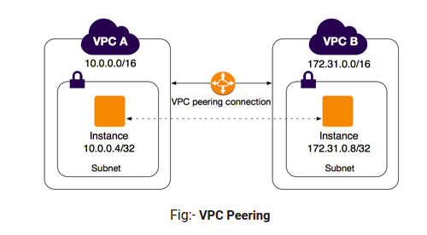

**What Is VPN?**

A virtual private network is a technology that allows users to establish a secure, encrypted connection to a network over the internet.

Companies commonly use VPNs to connect remote workers to their network, enabling access to resources that would otherwise be unavailable outside of the company’s physical location.

They’re also used to add an extra layer of security when accessing the internet from public WiFi networks, as VPNs encrypt all data transmitted between the user’s device and the network they’re connected to.

VPNs can be used to bypass geo-restrictions on content by allowing users to connect to servers in different locations around the world, making it appear as if they’re accessing the internet from a different country.

Overall, VPNs are an important tool for maintaining security and privacy when accessing the internet and connecting to networks remotely.

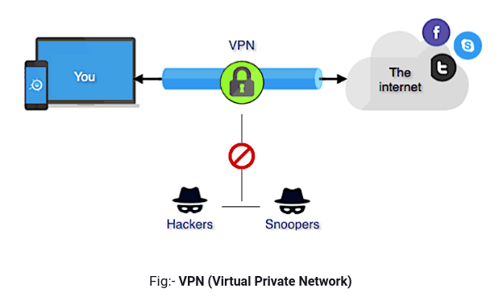

**VPC vs VPN**

VPN (Virtual Private Network) and VPC (Virtual Private Cloud) are related but distinct concepts used in networking and cloud computing.

A VPN is a technology that allows users to create a secure and private connection over a public network, such as the internet. It establishes an encrypted tunnel between the user’s device and a VPN server, ensuring that data transmitted between them remains confidential and protected from interception. VPNs are commonly used to enhance privacy, access restricted resources, bypass geographical restrictions, and provide secure remote access to corporate networks.

On the other hand, a VPC is a virtual network infrastructure provided by cloud computing platforms, such as Amazon Web Services (AWS) or Microsoft Azure. It enables users to create isolated and logically segmented networks within the cloud environment. A VPC allows you to define and control networking resources like subnets, IP addresses, routing tables, and security groups, much like you would do in a traditional on-premises network. VPCs provide the foundation for deploying and connecting cloud resources securely.

Although VPN and VPC are related in the sense that they both deal with private networks, they serve different purposes:

1. VPN operates at the network layer, providing secure communication between devices over public networks.
2. VPC operates at the infrastructure layer, allowing users to create and manage virtual network environments within a cloud computing platform.

In some cases, VPNs can be used to connect on-premises networks to a VPC, establishing a secure connection between the local network and the virtual network in the cloud. This enables secure and private communication between the two environments, extending the on-premises network to the cloud.